Re: Welcome to Formentera

Properties owned by Revolution Resources, LLC and Revolution NPI Holding Company, LLC (together “Revolution”) in Canadian, Logan, Oklahoma, and Kingfisher County, Oklahoma, in which you own an interest have been purchased and are now operated by Formentera Operations LLC (“Formentera”).

As part of this transaction, Formentera is assuming activities beginning January 1, 2023, regarding the handling, processing, and payment of revenue related to the wells previously operated by Revolution Resources, LLC. Beginning with your payment in January (for November gas/oil, and December oil), your revenue check will be issued by Formentera.

For your revenue via ACH direct deposit, please fill out and return the enclosed Direct Deposit Agreement Form, and W-9 Form, to the address listed at the bottom of this letter. Due to timing of the acquisition and check run, owners should expect to receive at least one physical check.

Formentera has partnered with MineralAnswers.com, who is leading the way to empower owners with a modern owner portal, where they can access their PDF and digital statements. More information can be found about MineralAnsswers.com, on the included flier, and on their website – MineralAnswers.com.

Additionally, please complete the enclosed contact form to ensure Formentera has the most up to date information. More information on Formentera can be found at formenteraops.com.

If you have questions concerning this matter, please contact the Formentera owner line at (512) 646-0881 or ownerinquiry@formenteraops.com.

Respectfully,

Owner Relations Team
Formentera Operations, LLC

CONTACT INFORMATION FORM
Formentera Operations, LLC
Attn: Division Order Department
303 Colorado, STE 2050
Austin, TX 78701
OwnerInquiry@FormenteraOps.com

Owner Number:
Name on Account:
Contact Name:
Tax ID or SSN:
Telephone No.:
Email Address:
If the address needs to be updated from address on letter, please update below:

Address Line 1
Address Line 2
City |  |  | State |  | ZIP

Signature of Owner/Agent: ________________________________________________________

Print Owner Name: _________________________________________________________
Date: _____________________

PLEASE EMAIL A SCANNED COPY OF THIS FORM TO THE EMAIL ABOVE, OR MAIL A COPY TO THE ADDRESS LISTED ABOVE

PLEASE NOTE:
IF AN INDIVIDUAL: Address change requests must be executed by the person or agent for whom the address is being updated.
IF A CORPORATION, LLC, TRUST, ESTATE OR ANY ENTITY OTHER THAN AN INDIVIDUAL: The
person signing the address change request form must have the authority to make the request and documentation verifying said authority must accompany the address change request form for Formentera Operations’ records to be updated.

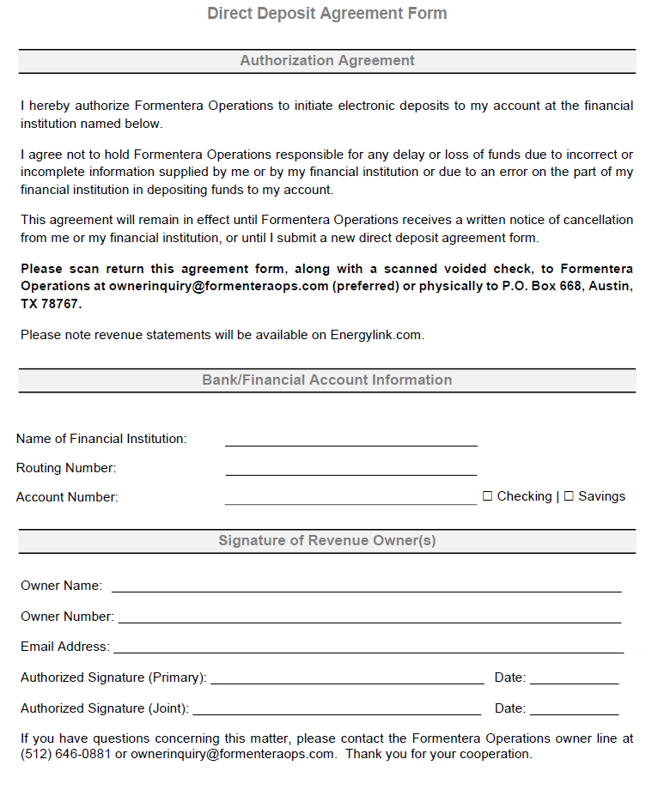

New Owner Portal on MineralAnswers.com

Signup Information

We’re excited to announce that Formentera is working with MineralAnswers.com to provide your Revenue / Royalty and JIB statements on their secure website. MineralAnswers.com is the new standard for statement management and regulatory information services. You’ll be able to access your information 24/7 and it will be available in both PDF and digital formats.

You can create your account by following this link, or scanning the QR code below with your phone’s camera.

Visit the sign-up link in a web browser: https://qrco.de/bcoJ73

Or Scan the QR code below:

